# Class variable, instance variable, class method, instance method, static method, instantiation ,instance attribute

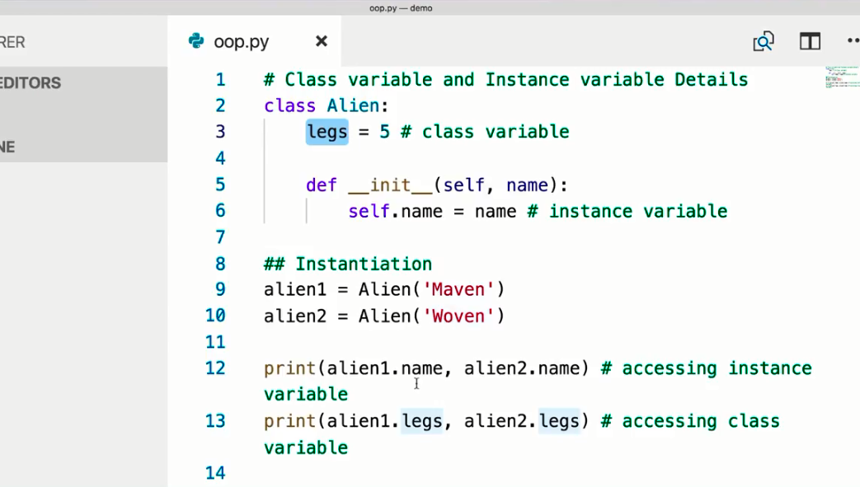

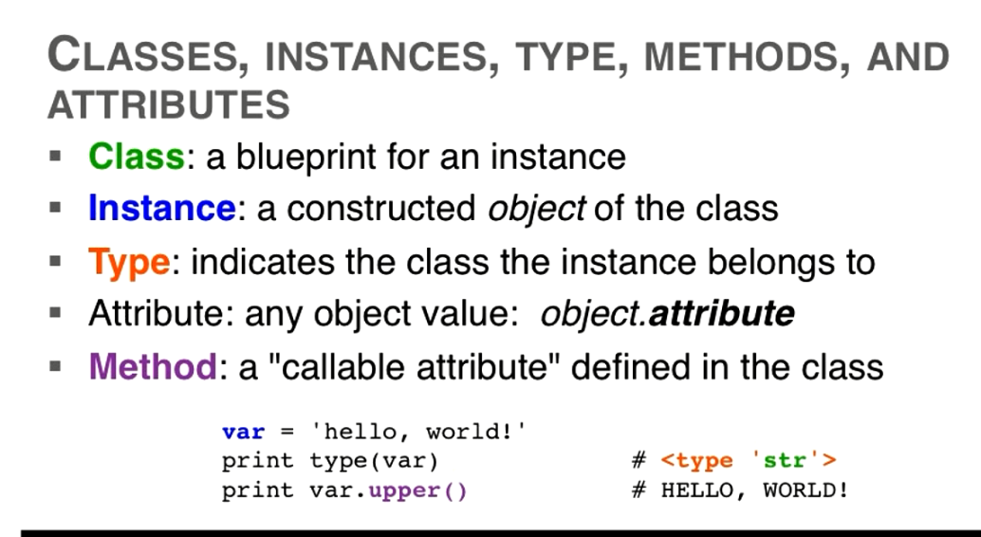

## Method

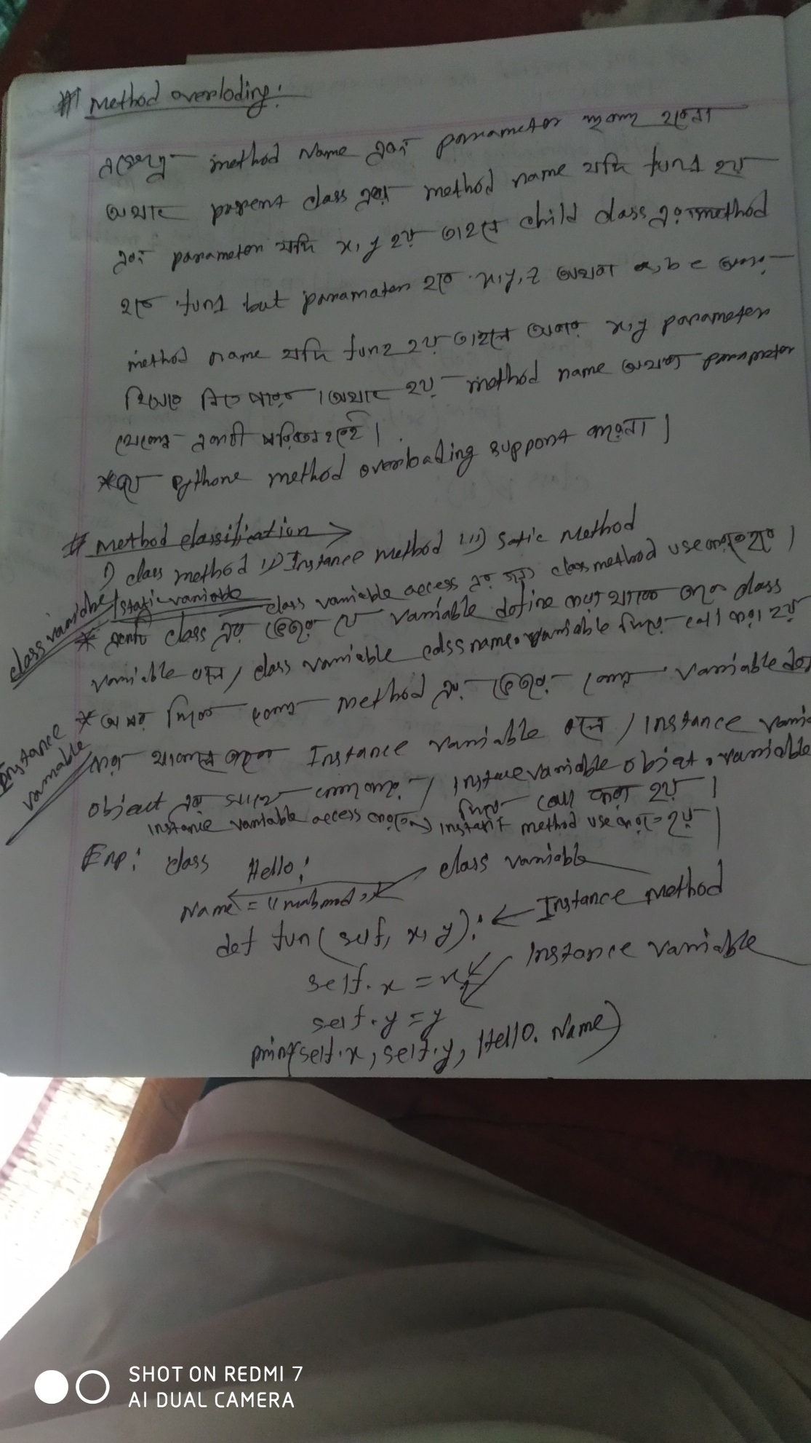

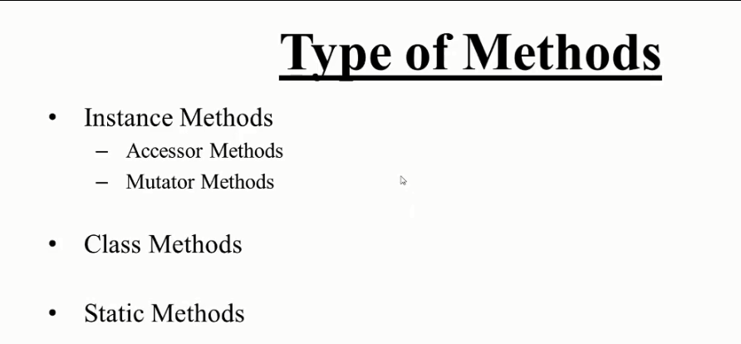

## Instance method

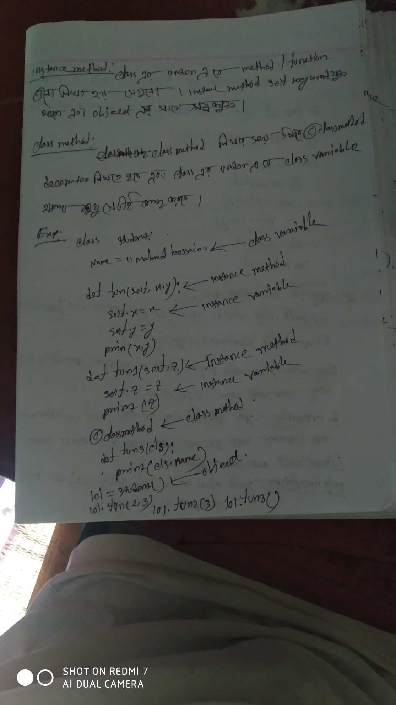

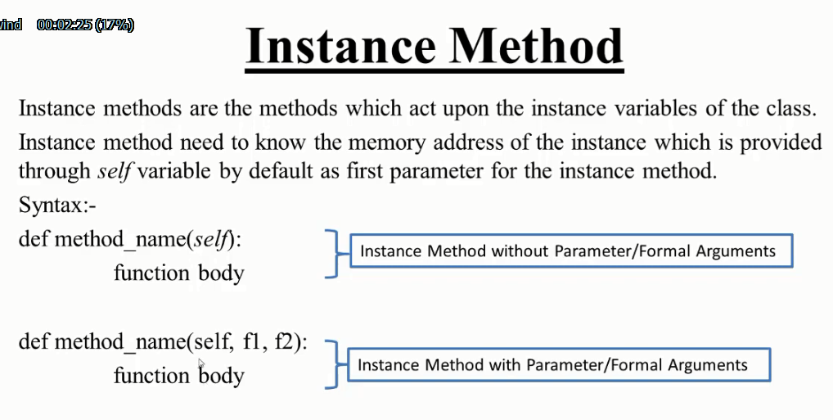

### Instance method without parameter

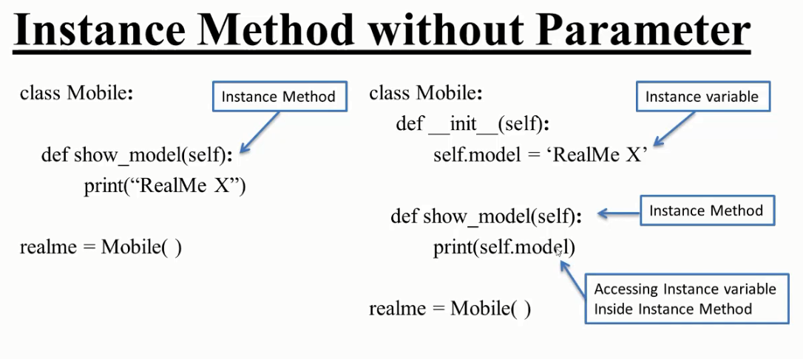

*#example with method*

class two:

**def** fun(*self*):  *#instance method*

        print('i am instance method without parameter')

lol**=**two()

lol.fun()

*#example with constuctor*

class one:

**def** __init__(*self*):   *#instance method*

*self*.name**=**'mahmud'  *#instance parameter*

**def** fun(*self*):

        print(*self*.name)

lol**=**one()

lol.fun()

### Instance method with parameter

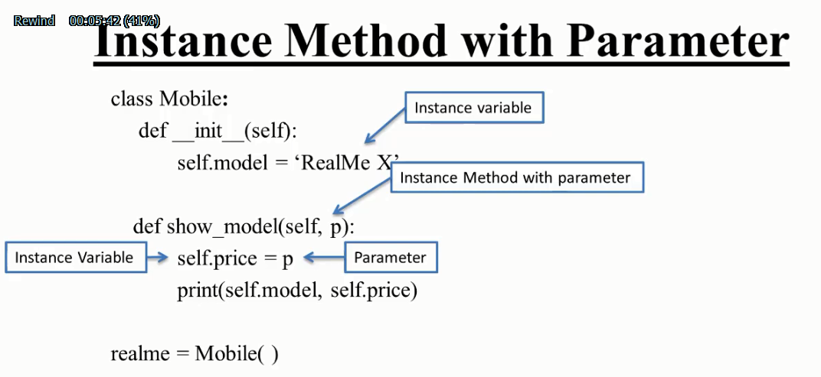

*#example with method*

class two:

**def** fun(*self*,**x**):  *#instance method*

*self*.x**=**x

        print('i am instance method with parameter of x:', x)

lol**=**two()

lol.fun(12345)

*#example with constuctor*

class one:

**def** __init__(*self*):   *#instance method*

*self*.name**=**'mahmud'  *#instance parameter*

**def** fun(*self*,**s**):

*self*.s**=**s

        print(*self*.name)

        print(*self*.s)

lol**=**one()

lol.fun(12345)

## Class method

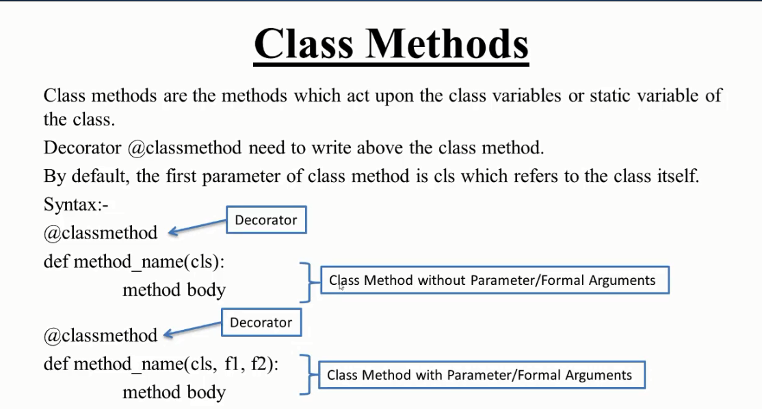

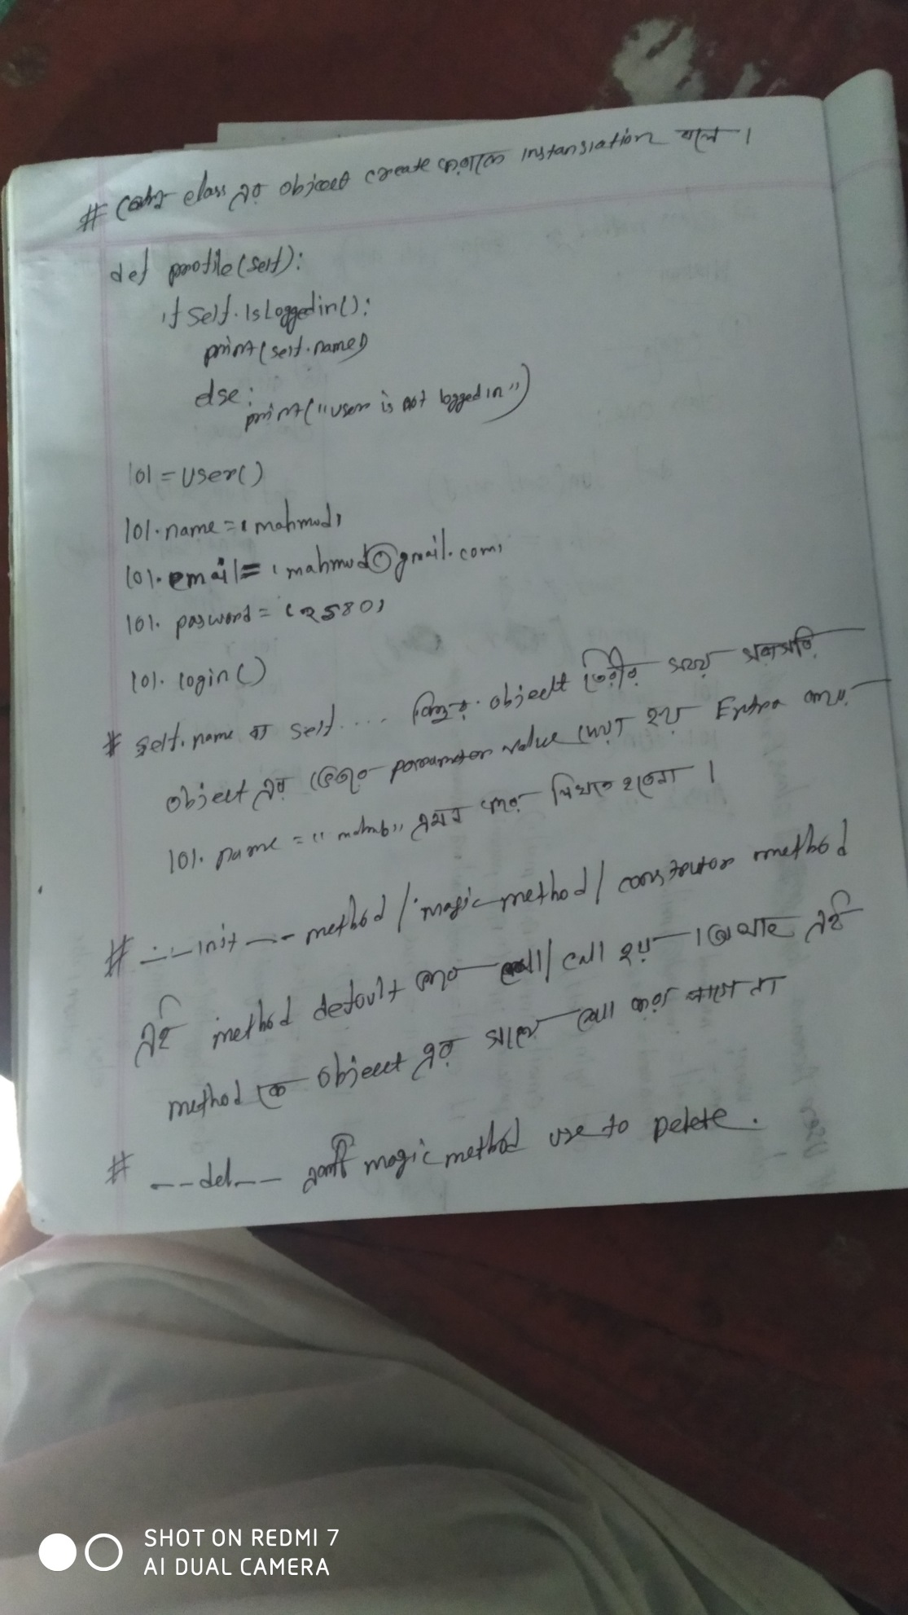



### Class method with and without parameter

#### Without parameter

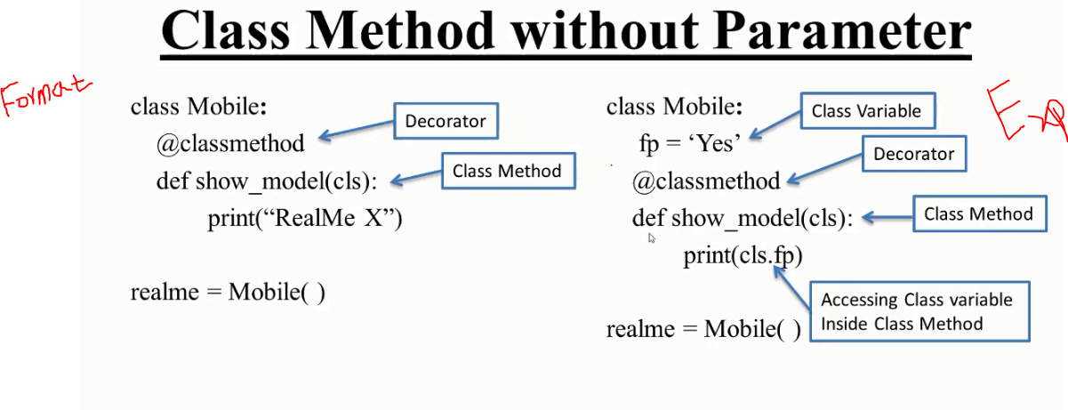

class one:

    x**=**'hello world'

    @classmethod

**def** fun(*cls*):

        print(*cls*.x)

lol**=**one()

lol.fun()

#### With parameter

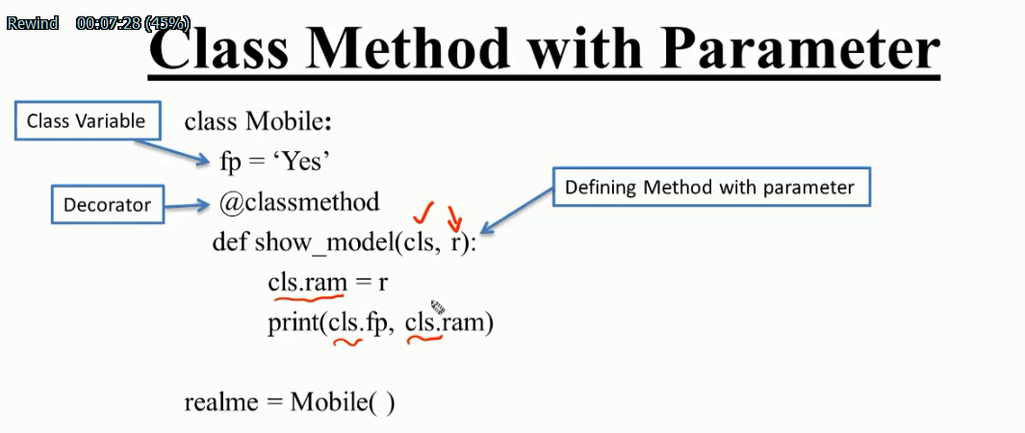

class one:

    x**=**'hello'

    @classmethod

**def** fun(*cls*,**y**):            *#same as self,y*

*cls*.y**=**y                *#self.y=y*

        print(*cls*.x, *cls*.y)    *#print(self.y)*

lol**=**one()

lol.fun(123)

## Static method

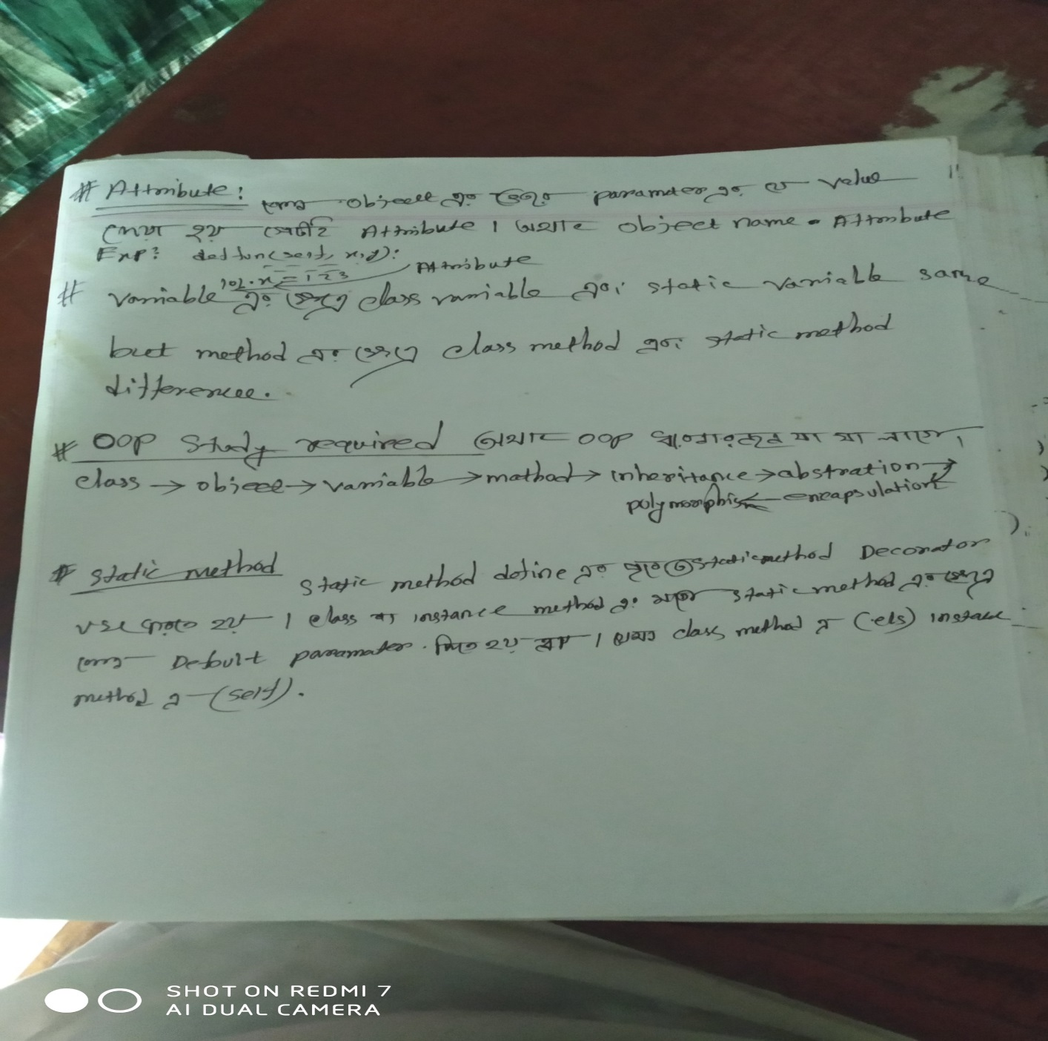

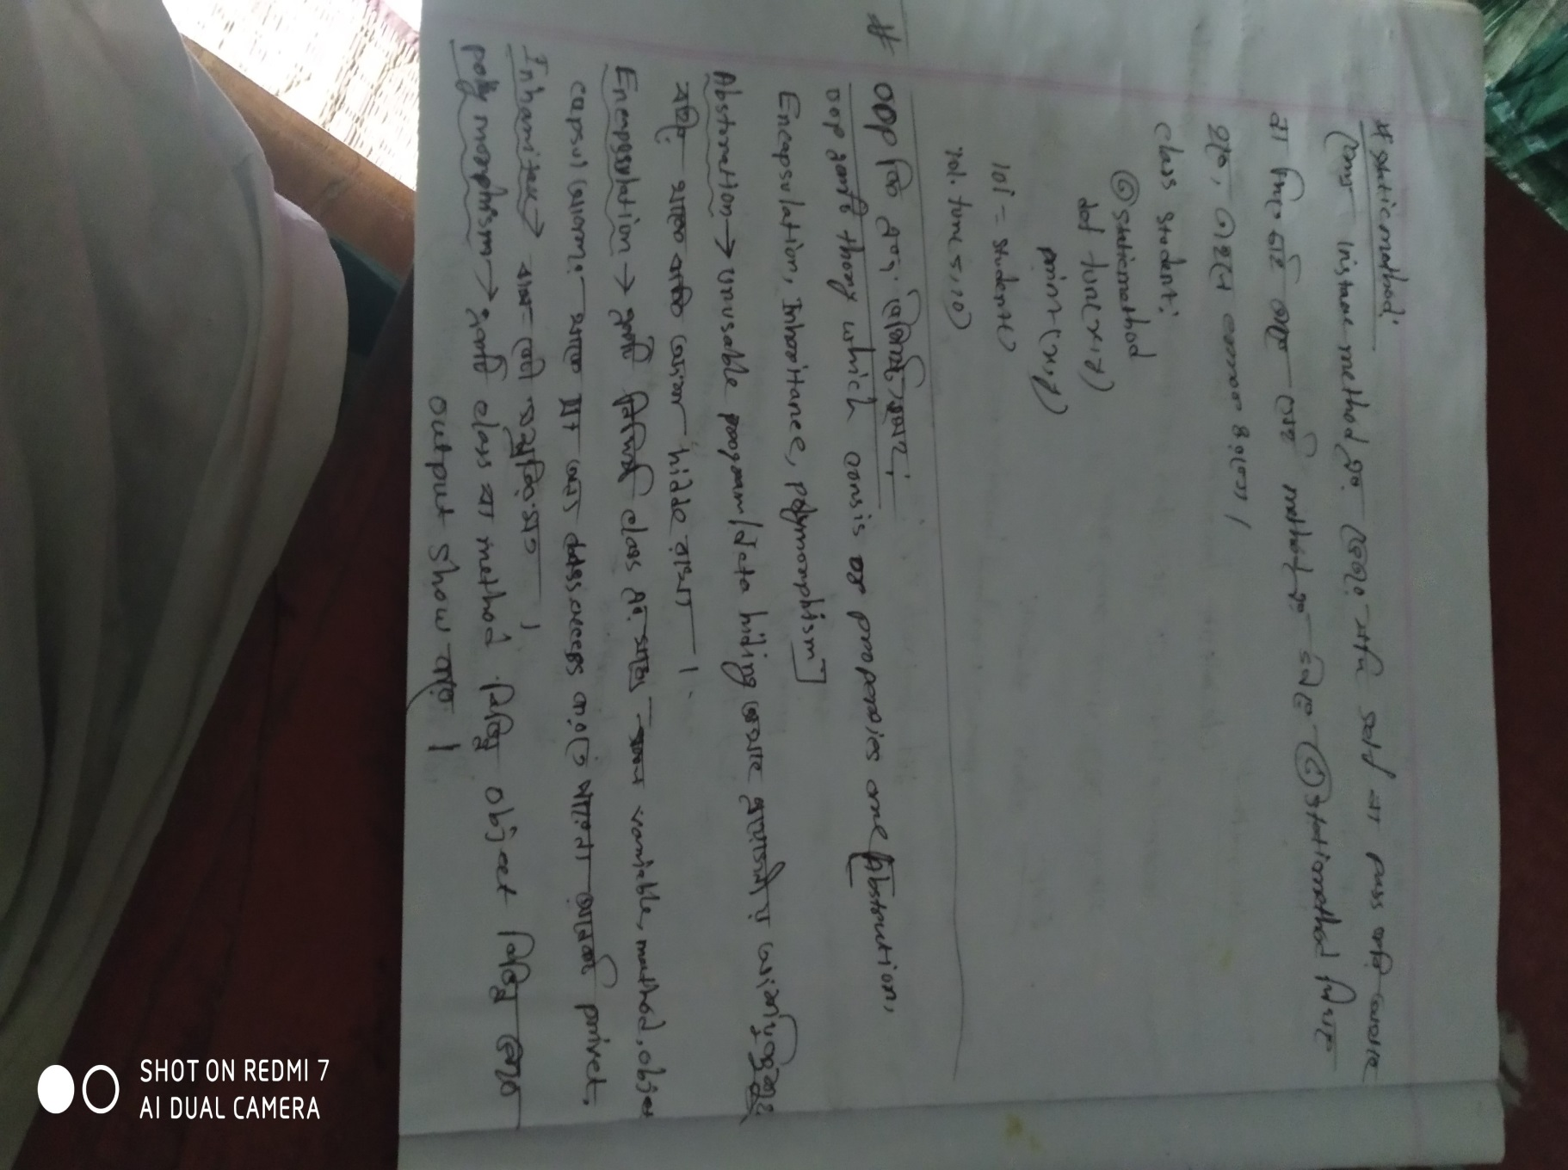

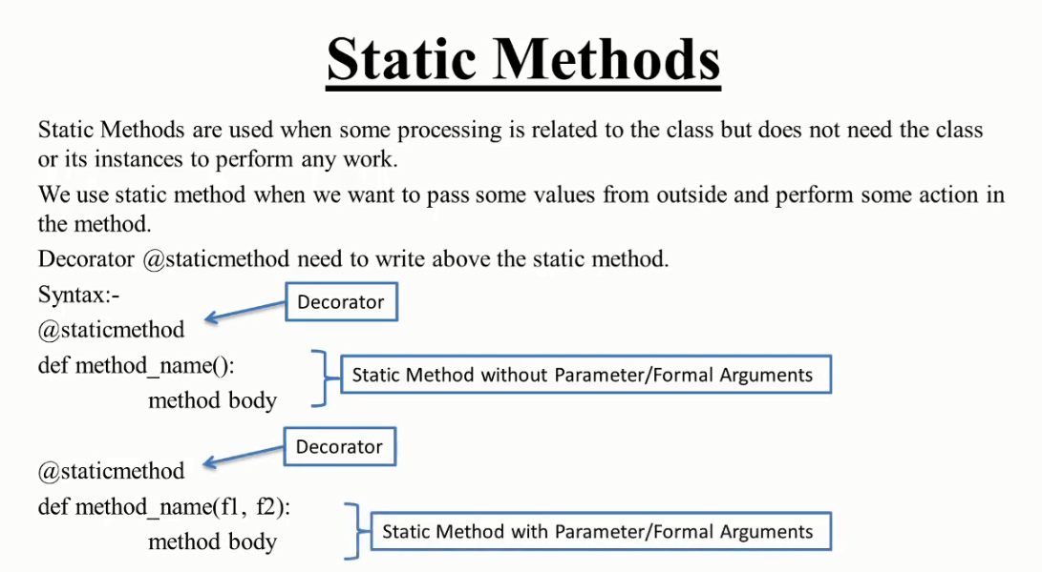

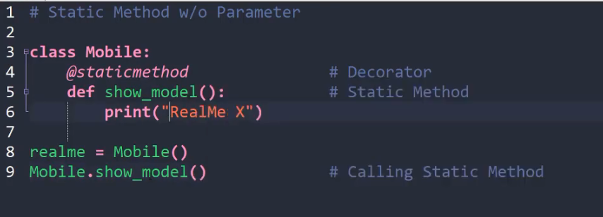

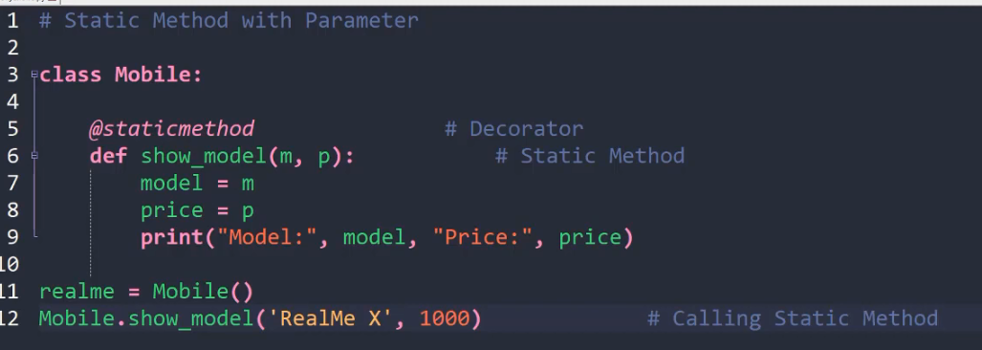

### Passing parameters/member from one class to another class by using static method

## Variable



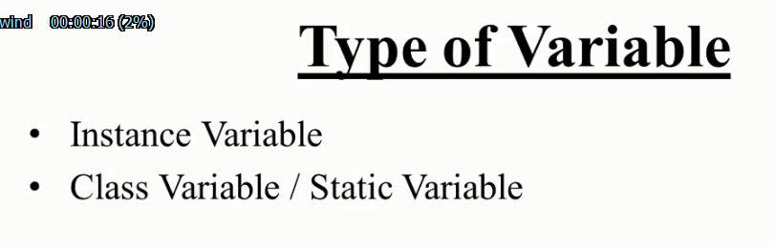

### Instance variable

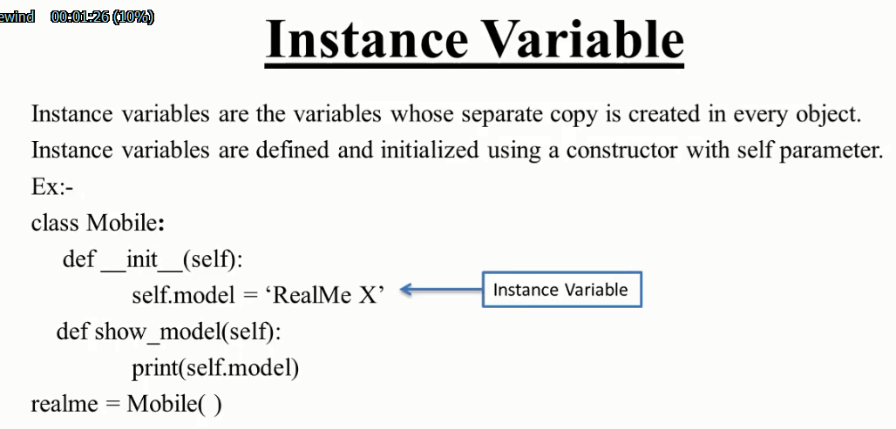

#### How to access instance variable inside class

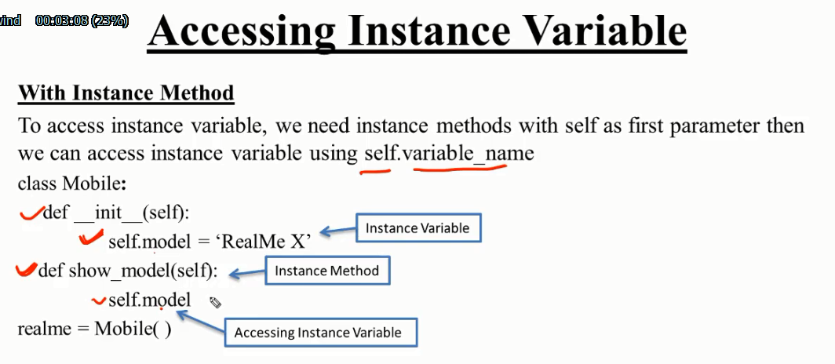

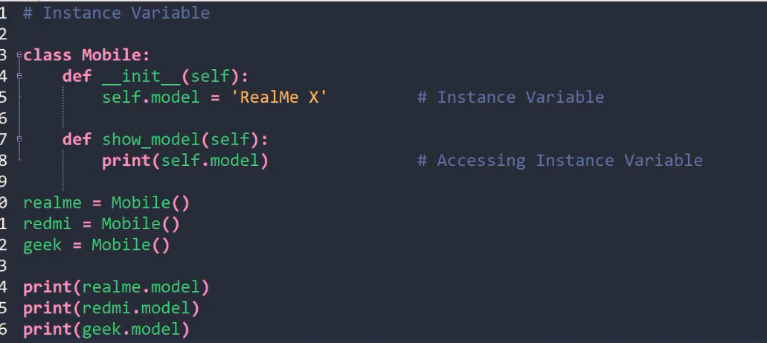

#### How to access instance variable outside class

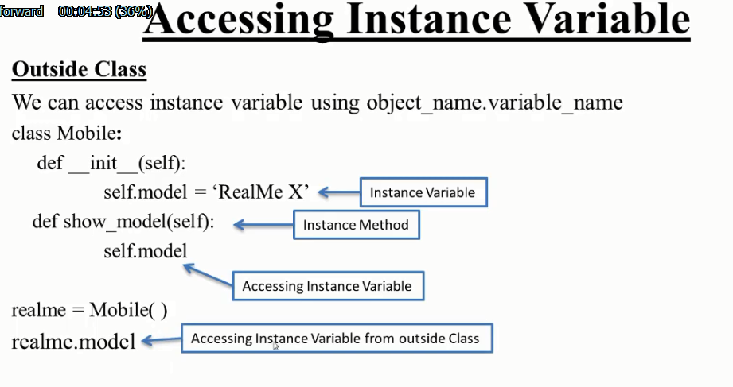

### Class variable /static variable

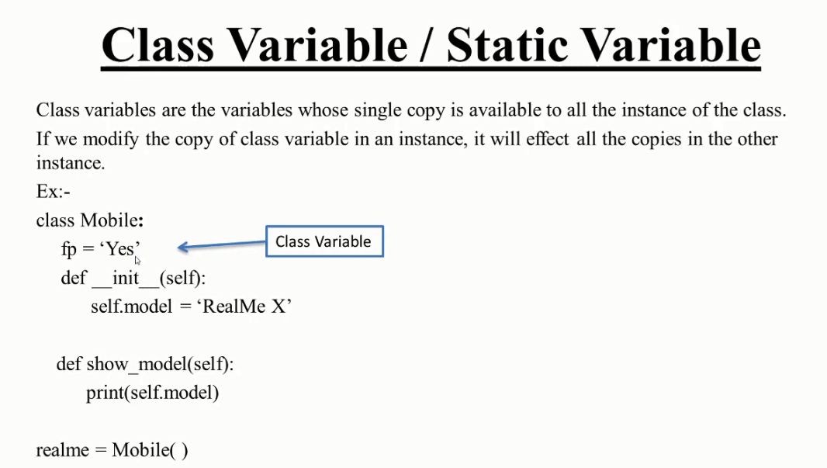

#### How to access class variable inside class

By using class method we can access it.

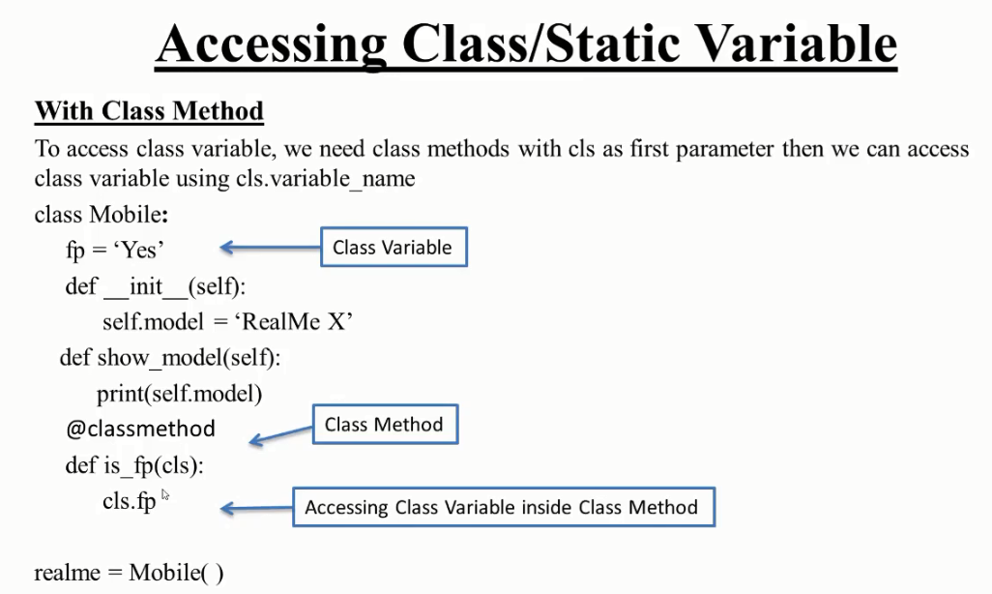

class one:

    x**=**111111111111111111111111111111111111111111111111111111

**def** fun(*self*):

        print('hello')

    @classmethod

**def** fun2(*cls*):

        print(*cls*.x)

lol**=**one()

lol.fun()

lol.fun2()

#### How to access class variable outside class

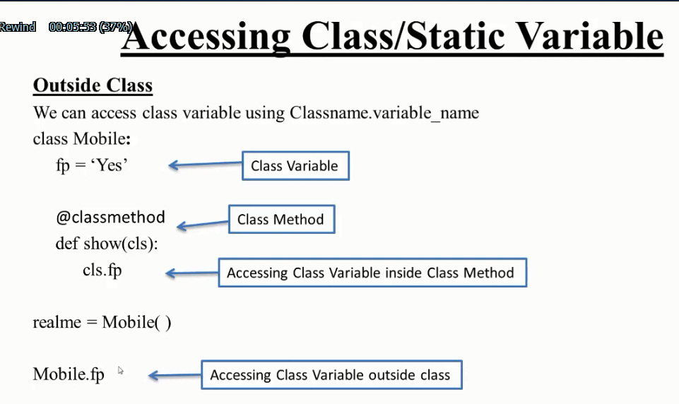

class one:

    x**=**111111111111111111111111111111111111111111111111111111

**def** fun(*self*):

        print('hello')

    @classmethod

**def** fun2(*cls*):

        print(*cls*.x)

lol**=**one()

lol.fun()

one.fun2()

exp2:

class one:

    name**=**'hossain'

**def** __init__(*self*):

*self*.x**=**'hello'

**def** fun(*self*):

        print(*self*.x)

    @classmethod

**def** fun2(*cls*):

        print(*cls*.name)

lol**=**one()

lol.fun()

one.fun2()

#### statically change class variable parameter value

class one:

    name**=**'hossain'

**def** __init__(*self*):

*self*.x**=**'hello'

**def** fun(*self*):

        print(*self*.x)

    @classmethod

**def** fun2(*cls*):

        print(*cls*.name)

lol**=**one()

lol.fun()

*#one.fun2()*

one.name**=**'mahmud'

one.fun2()